PRACTICAL 2

Suppose that a data warehouse for Big University consists of the following four

dimensions: ‘student’, ‘course’, ‘semester’, and ‘instructor’. Further, assume there are two measures ‘count’ and ‘avg_grade’. The measure ‘count’ refers to number of students. When at the lowest conceptual level (e.g. for a given student, course, semester, and instructor combination), the ‘avg_grade’ measure stores the actual course grade of the student. At higher conceptual levels, ‘avg_grade’ stores the average grade for the given combination.

(a) Draw a snowflake schema diagram for the data warehouse.

(b) Starting with the base cuboid [student; course; semester; instructor], what specific OLAP operations (e.g., roll-up from semester to year) should one perform in order to list the average grade of CS courses for each Big University student.

(c) If each dimension has five levels (including all), such as “student < major < status < university < all", how many cuboids will this cube contain (including the base and apex cuboids)?

a)

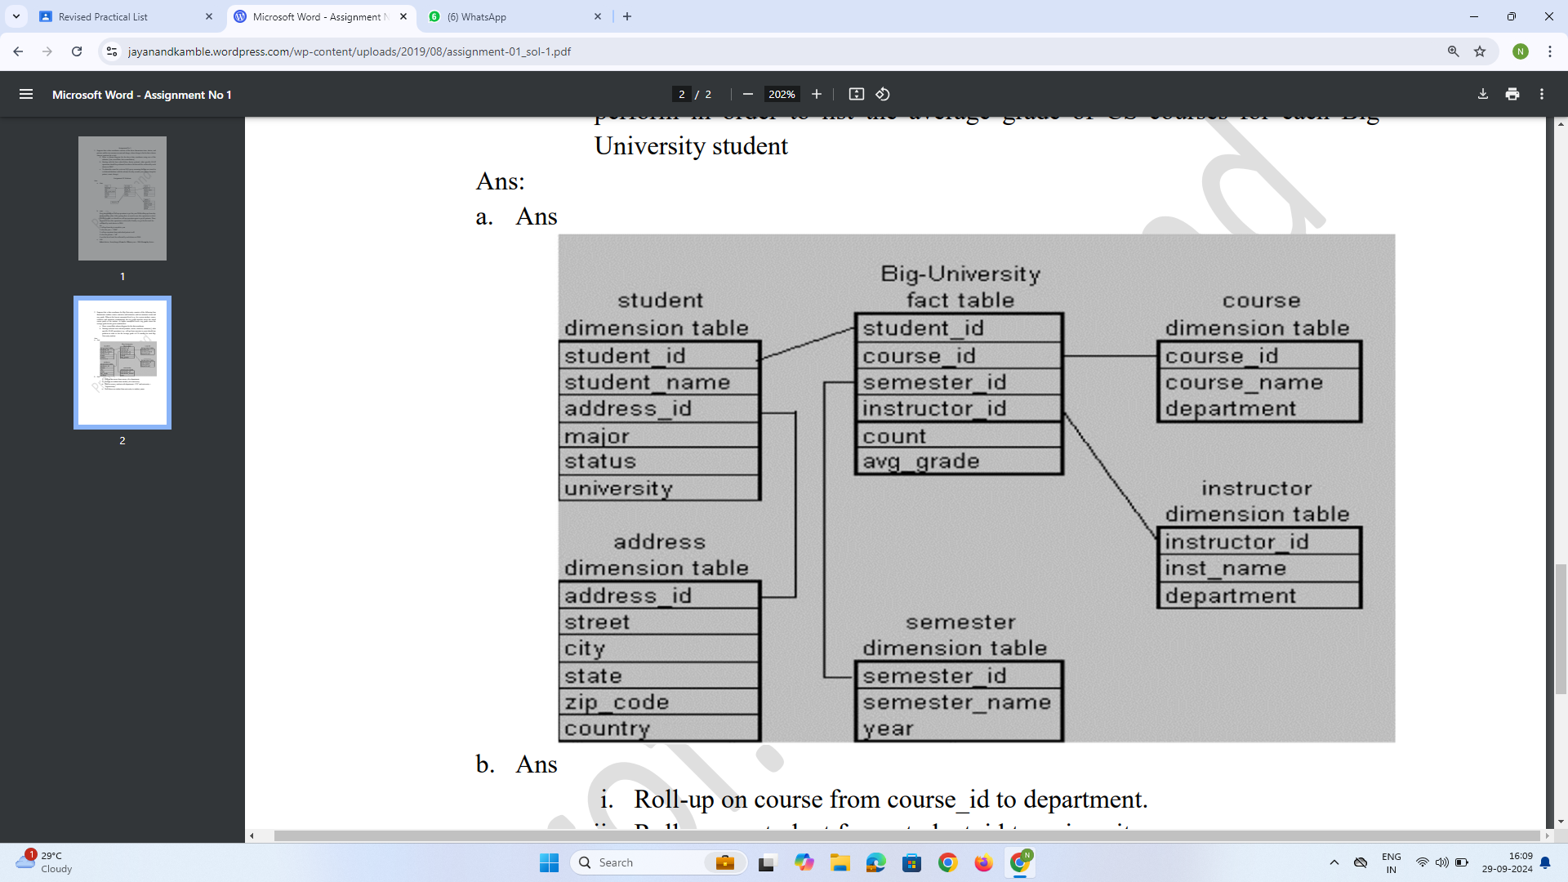

b)

i. Roll-up on course from course_id to department.

ii. Roll-up on student from student_id to university.

iii. Dice on course, student with department ="CS" and

university = "biguniversity"

iv. Drill-down on student from university to student_name.

c)

Li = 5-1 =4

N=4 dimensions

So, this cube will contain (Li+1)^4 = 625 cuboids